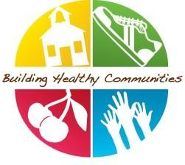

Healthy Champion Communication-December
The wintry weather marks the impending change of seasons and brings us closer to the school break. No doubt many of your young learners are 'beginning with the end in mind" this month (and some of their teachers too!). While many are looking forward to the year-end, there is still plenty of time for a focus on healthy, active kids. Thank you for your work to help your school build healthy habits- you are doing a great job!
During the Month of December:
- Schedule your monthly check-in with your BHC coordinator and complete your monthly survey (DUE DEC 6)!
- Promote classroom healthy eating lessons: We recommend the Grains lesson in the month of December. Check out this whole grains experiment to help reinforce what students learned in their monthly lessons.

- Edit and send the December staff email here!

- Ensure healthy tips of the day are being communicated as well as newsletter inserts and parent tip sheets.

- Optional: You can earn a $50 gift card for personal use if you email me 7 pictures by January 26th. See the instructions if you are interested in participating.
Quick Links
- Whole Grains Video
- December PA Breaks
- December Newsletters Inserts
- December Healthy Announcements
- December BHC Staff Email
- Healthy@home: Tips sheets available to share this month- Celebrate Healthily, Healthy Celebrations, Screen Time, Family bonding activities. You can find the png versions of these here in case you want to post them on your school's social media accounts. Don’t forget there is a Parent Tip Page on our website. This link allows your parents to translate the monthly tip sheet into the available language options.

