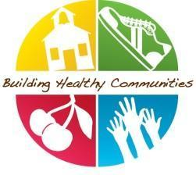

Healthy Champion Communication-January

Dear Healthy Champions, Welcome back from your Holiday Break!
This month in BHC, you should aim to:
- Edit and send your staff monthly communication-here
- Schedule your monthly check-in with your BHC coordinator and complete your monthly survey (DUE JAN 10)!
- Promote Healthy Eating lessons: The Protein lesson January's primary lesson. Please ensure students watch the video and talk through the discussion questions. What's your healthy eating style is a great companion lesson for classrooms interested in going deeper.
- Encourage your staff to continue to make recess a priority regardless of weather conditions with our indoor recess resources and January PA breaks here.
Quick Links
- January BHC Staff Email
- Protein Video
- January PA Breaks
- January Newsletters Inserts
- January Healthy Announcements
- Healthy@home: Magic of Mealtime highlights the benefits of family mealtimes and Protein focuses on many ways to get the protein your body needs. If your school would like to post any of our parent tips on social media click here to download them in Png format.Don’t forget our Parent Tip Page on the BHC website. This link allows your parents to translate the information into the available language options.

