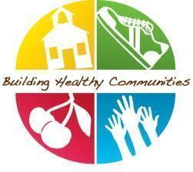

Healthy Champion Communication: April
Dear Healthy Champions, Welcome to April with BHC!

This month in BHC, you should aim to:
- Edit and send the April staff communication here!

- Complete your March Healthy Champion survey by Friday, April 11th and sign up for your monthly check-in with your BHC Coordinator.

- Promote classroom healthy eating lessons: Healthy Breakfast and Around the World.

- Prioritize Recess! As the weather gets warmer make sure your school's recess carts are accessible for regular use. Recess is an important part of a student's day and benefits them both physically and emotionally. Share with your school staff and recess monitors our BHC resource for restorative recess.

- Your school has been working hard this year to implement healthy changes. Before the end of the year, we would love to hear about what you think the biggest successes have been improving your school environment. For examples of past school successes view this resource here!
Quick Links
- Healthy Breakfast Video
- April PA Breaks
- April Newsletters Inserts
- April Healthy Announcements
- Healthy@home: Ensure that the Healthy@Home resources: Healthy Breakfast & Coping with Childhood Stress are shared. Don’t forget our Parent Tip Page on the BHC website. This link allows your parents to translate the information into the available language options if needed.

